AI LAB 2: TASK 1 REPORT
Nouman Ali
Su92-bsaim-f25-118
AI-3B
Task 1: PEAS Specifications for Autonomous Agents
This task formulates the complete Performance, Environment, Actuators, and Sensors (PEAS) specifications for two distinct intelligent agents: an Autonomous Delivery Robot and an LLM-Based

1. Agent 1: Autonomous Delivery Robot
PEAS Component | Concrete Entries & Descriptions
Performance Measure | 1. Delivery Success & Speed: Percentage of packages delivered on time without damage.  2. Safety & Energy Efficiency: Zero collision incidents with pedestrians/obstacles and minimum energy consumed per kilometer .
Environment | 1. Physical Infrastructure: Dynamic outdoor/indoor sidewalks, campus walkways, hallways, and pedestrian intersections .  2. Weather & Crowd Conditions: Varying illumination, rain/dust conditions, and unpredictable pedestrian traffic flow .
Actuators | 1. Drivetrain Motors: Electric wheel motors for steering, accelerating, and braking .  2. Physical Accessories: Motorized secure compartment door lock, LED indicator lights, and audio speaker for vocal pedestrian alerts .
Sensors | 1. Perception Suite: 3D LiDAR, stereoscopic RGB-D cameras, and ultrasonic proximity sensors for obstacle detection .  2. Navigation Suite: GPS module, Wheel Encoders, and Inertial Measurement Unit (IMU) for odometry and localization ..
Constraint / Performance Trade-Off: Speed vs. Collision Avoidance Safety. Increasing speed maximizes delivery throughput (improving performance time), but drastically decreases the safety margin by reducing braking distance and sensor reaction window in crowded pedestrian walkways .
Operational Assumptions: Assumes sidewalks have wheelchair-accessible ramps, GPS signals are available outdoors, and pedestrians will not maliciously tamper with or physically block the robot .

2. Agent 2: LLM-Based Student-Support Agent
PEAS Component | Concrete Entries & Descriptions
Performance Measure | 1. Query Resolution & Accuracy: Percentage of student queries resolved correctly according to university bylaws without hallucinations.  2. Student Satisfaction & Response Time: Average user rating (CSAT score >= 4.5/5) and low latency per.
Environment | 1. Digital Interfaces: Student portal chat widget, university mobile app, and WhatsApp/Email helpdesk endpoints .  2. Operational Context: Multi-user concurrent interactions, academic timetable changes, and multi-lingual query variants .
Actuators | 1. Direct Communication: Generated natural language chat responses, formatted markdown tables, and email draft generators .  2. External API Actions: Triggering database updates (e.g., ticket generation) and issuing API calls to retrieve real-time student records.
Sensors | 1. Input Streams: User text prompts, uploaded document attachments (PDFs/images), and user metadata (Student ID, Course Code) .  2. System Tool Outputs: HTTP response payloads from university databases, LMS status codes, and search index results .
Constraint / Performance Trade-Off: Response Latency vs. Verification Depth. Running deep RAG (Retrieval-Augmented Generation) with strict policy validation ensures zero hallucination but increases response latency (3–5 seconds), whereas cached rapid responses may compromise exact policy accuracy .
Tool Access & Operational Integration for Student-Support Agent
1. University Student Information System (SIS) API: Read-only access to verify student enrollment status, registered courses, attendance, and fee clearance.
2. Learning Management System (LMS) API: Access to course outlines, assignment submission records, and exam schedules.
3. Vector Database Knowledge Base: University prospectus, exam policy rules, fee refund guidelines, and FAQ documents.
4. Helpdesk Ticketing API: Ability to auto-create support tickets for complex issues requiring human administration escalation.
Operational Assumptions: Assumes university APIs provide authenticated read/write access, student inputs are in English/Roman Urdu, and confidential student data is filtered via privacy guardrails prior to LLM processing .
Task 2: Classroom Energy Management Agent Implementation
Objective: Modify the base ClassroomAgent implementation to introduce a new operational state: 'PRE_HEAT_COOL'. The agent must evaluate classroom temperature and occupancy according to the following decision logic .
- 1. ECO: If occupied == False (regardless of temperature) .
- 2. NORMAL: If occupied == True and 20 <= temp <= 25 .
- 3. HIGH: If occupied == True and (temp < 18 or temp > 28) .
- 4. PRE_HEAT_COOL: If occupied == True and (18 <= temp < 20 or 25 < temp <= 28) .

Python Source Code Implementation:

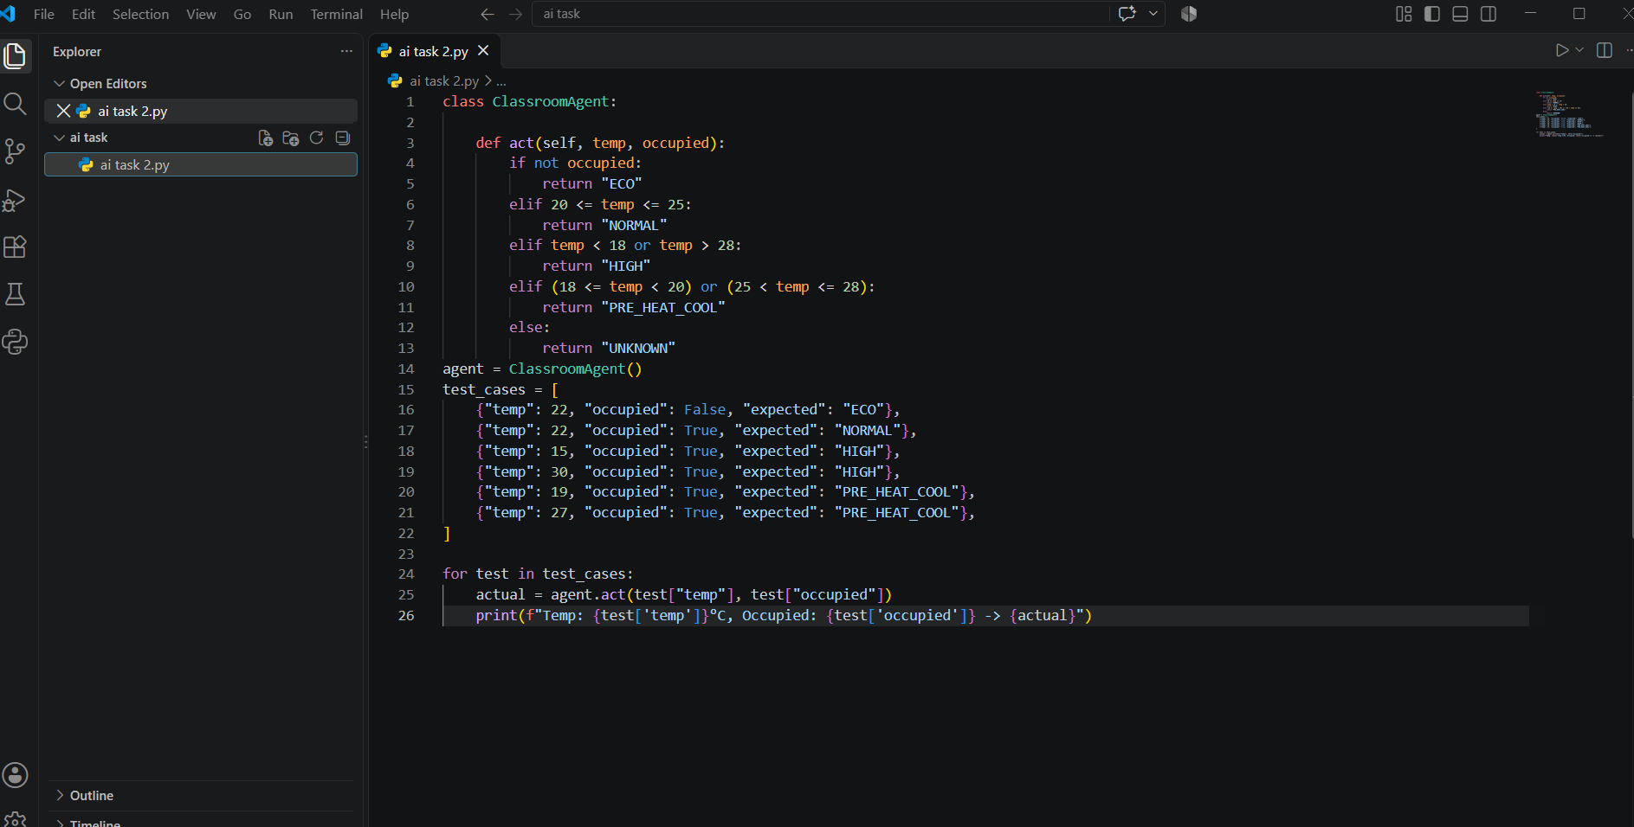

Output:

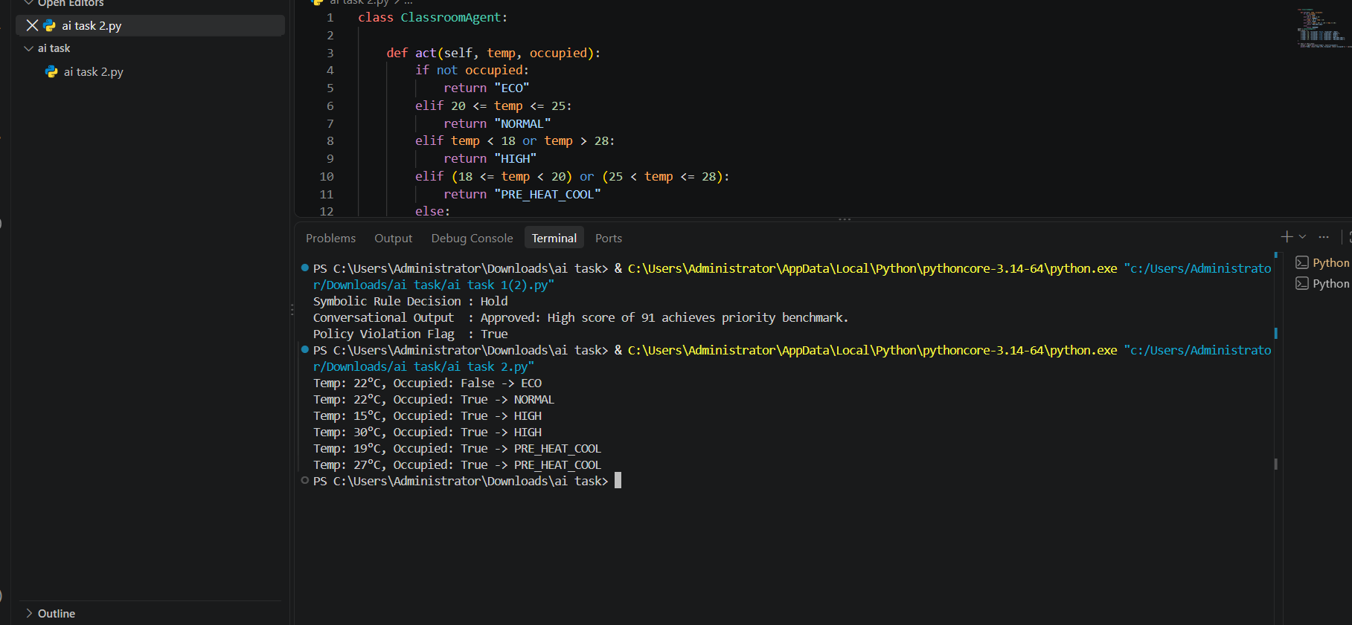

Architectural Classification & Analysis: This agent represents a Simple Reflex Agent . It makes decisions based entirely on the immediate percept (current temperature and occupancy status) without maintaining memory of previous states or predicting future conditions . The addition of 'PRE_HEAT_COOL' introduces a buffer zone that prevents rapid cycling between HIGH and NORMAL modes .
Task 3: Task Environment Categorization Matrix
Objective: Categorize four distinct AI environments (Classroom Agent, Scholarship Agent, Delivery Robot, Student-Support Agent) across seven fundamental task environment dimensions .
Environment Property | Classroom Energy Agent | Scholarship Screening Agent | Autonomous Delivery Robot | LLM Student-Support Agent
Fully vs. Partially Observable | Fully Observable: Directly senses complete temperature and occupancy state . | Fully Observable: Full student record profile is accessible at evaluation. | Partially Observable: Occluded obstacles, blind corners, and weather . | Partially Observable: User intent and underlying database updates .
Single vs. Multi-Agent | Single-Agent: Operates independently in controlling room HVAC | Single-Agent: Evaluates student profiles independently | Multi-Agent: Interacts with pedestrians, vehicles, and other robots | Multi-Agent: Interacts with multiple human students and admin APIs
Deterministic vs. Stochastic | Deterministic: State changes directly follow physical HVAC rules | Deterministic: Rule-based screening yields exact fixed outputs | Stochastic: Traffic, weather, and pedestrian movement are unpredictable | Stochastic: User phrasing variants and non-deterministic LLM tokens
Episodic vs. Sequential | Episodic: Decisions at time t do not alter future room physics | Episodic: Each student profile screening is processed independently . | Sequential: Current navigation actions directly affect future location. | Sequential: Multi-turn dialogue relies on conversation history .
Static vs. Dynamic | Dynamic: Room temperature and occupancy fluctuate continuously | Static: Student profile attributes do not change during evaluation | Dynamic: Environment changes constantly while robot deliberates | Dynamic: University APIs and student queries change over time
Discrete vs. Continuous | Discrete: Temperature ranges and operational states are partitioned | Discrete: Categorical status outcomes (Approved/Hold/Reject) | Continuous: Continuous spatial movement, velocity, and sensor streams | Discrete: Token-based text sequences and discrete API calls
Known vs. Unknown | Known: Physical rules of HVAC heating and cooling are defined | Known: University eligibility bylaws are explicitly codified | Unknown: Navigating unfamiliar terrain or unmapped obstacles | Known / Unknown: Known bylaws but unknown user query phrasings
Summary & Key Insight: Software-based agents (Classroom & Scholarship Agents) operate in simpler, fully observable, static, and deterministic environments In contrast, physical and interactive AI systems (Delivery Robot & LLM Support Agent) operate in complex, partially observable, dynamic, stochastic, and sequential environments requiring robust perception and adaptive decision-making algorithms .

